**INTRODUCTION**

Robin, a local artist, wants to go into business printing custom apparel. She wants to sell the apparel to organizations at the local University. She got encouragement to start the business by her children and their friends as they always complimented the custom T-shirts made by Robin for their various clubs and sports activities. In order to start the business, she wants to hire a part-time worker to handle all the relevant information. She wants to keep a record of all the customer details and orders placed by them.

All these details should be well managed by the worker as she forecasts the spike in the sales in the first year. Moreover, there should be a product list for all items such as hoodies, caps, hats, jackets, and t-shirts with their available size, colors, and prices. She wants to eliminate the need for writing customer information again and again on the order. She wants a faster way to take the orders as she will get quite busy with the increase in the business. As the majority of customers are college students, she wants to display budget-friendly items first. Also, she wants easy modifications in the price list of the items. In order to increase the sale, she wants to know about the best selling products and list of frequent trustworthy customers.

In addition to this, she also wishes to know about the customers who have some unpaid bills so that she could forward this list to her collection agency. To create more repeat business she is planning to give discounts to the customers from nearby cities.

**USE OF DATABASE**

As Robin is planning to expand her business, she will no longer be able to manage things manually. It will be very cumbersome and time-consuming. The database will consist of various tables and various queries will be performed on them for the retrieval of relevant data.

In order to run an apparel business smoothly, Robin will need database for the following operations:

1. To store all the personal information of her customers like their name, address, and phone number. It will help to contact the customer in certain issues and will also keep the track of which customers are more frequent ones.
2. To store the order information like date of order, product names, size, quantity, etc. It will allow for easy modification of products.
3. To maintain a list of all available products with their name, prices, and description. Some of the products which she sells include hoodies, T-shirts, jackets , caps, and hats.
4. To maintain the billing procedure and to check about the due payments.
5. This will eliminate the need to do the same task repeatedly and will save time. For example, she will not hate to write customer addresses again and again on the orders placed by that customer.
6. It will help Robin to know about the best selling products.
7. It will allow her to identify the most frequent customers.
8. It will help Robin to identify which state holds the majority of customers so that extra discounts can be offered to them.
9. It will allow her to filter out budget-friendly products.
10. It will ease the identification of customers with unpaid bills.

Robin’s Apparel business database consists of the following tables:

**Table 1: Customer**

This table contains personal information such as customer name, city, street, state, postcode, and phone number

Constraints: Cust_ID uniquely identifies the rows, postcode field size is limited to 4 and phone number field size is limited to 9.

**Table 2: Orders**

This table consists of a unique order id along with the date of order and associates the corresponding customers using Cust_ID

Constraints: Order Number is unique and corresponding Cust_ID must exist in the Customer table.

**Table 3: Order Line Items**

This table consists of the details of orders placed by various customers. It consists of Order Number which is the foreign key, product Id which uniquely identifies every product in the Product table, description of the order such as size, color, and the quantity.

Constraints: corresponding Order number and Cust_ID must exist in Orders and Customer Tables respectively.

**Table 4: Product**

This table stores various products which are being sold by Robin. It has a unique product ID(Prod_ID) to identify every product along with the product name(Prod_Name). This table also stores the price corresponding to every product.

Constraints: Prod_ID is the primary key of the table.

**Table 5: Billing**

This table stores all the payment-related information. Each bill has a unique bill ID associated with every bill. It consists of an order number and customer ID for whom this bill is being generated. This table also stores the total amount of the bill. If the customer is unable to make the complete payment it will also store the remaining balance which will be helpful in identifying unpaid bills in the near future.

Constraints: Bill Number is the primary key of the table and the corresponding Order

number and Cust_ID must exist in Orders and Customer Tables respectively.

**ER DIAGRAM**

Entity Relation diagram displays the relationships of the entity sets stored in a database. In other words, we can say that ER diagrams help you to explain the logical structure of databases.

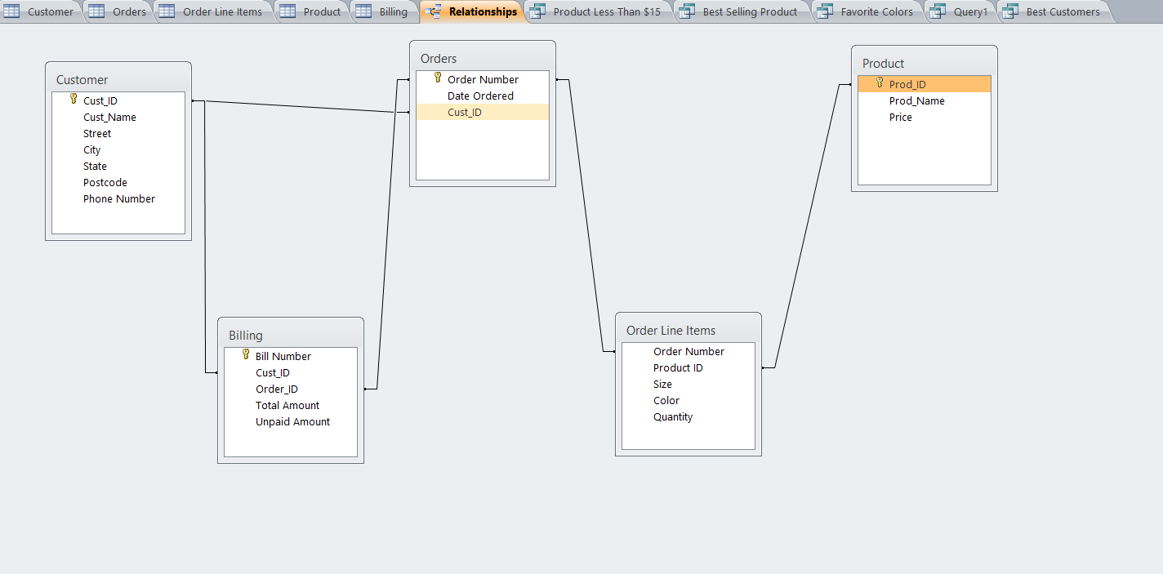

**ADDITIONAL QUERIES**

**Query 1: List the customers who have unpaid bills.**

This query will give the name, address, and phone numbers of all the customers who have to pay the remaining amount. Robin can forward this list to the collecting agency which will contact these customers and will collect the payment and will return it to Robin and later she should update this information in the database.

SELECT Customer.Cust_ID,Cust_Name,Street,City,State,Postcode,[Phone Number],[Unpaid Amount]

FROM Customer INNER JOIN Billing ON Customer.Cust_ID = Billing.Cust_ID

WHERE [Unpaid Amount]>0;

**Output:**

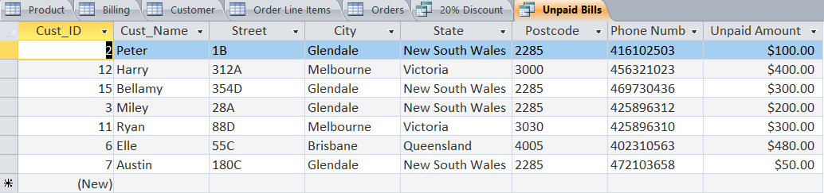

**QUERY 2: Give a 20% discount to the customers belonging to Glendale city.**

Robin wants to create more repeat business, so for that, she can give a 20% discount to nearby towns such as Glendale. This query will return new discounted bill for the orders from customers living in Glendale.

SELECT Cust_Name ,[Total Amount ] , ([Total Amount]-([Total Amount]*0.2)) AS [After Discount]

FROM Customer INNER JOIN Billing ON Customer.Cust_ID = Billing.Cust_ID

WHERE city="Glendale";

**OUTPUT:**

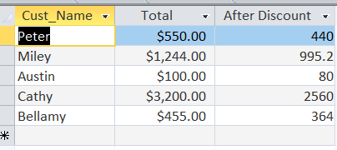

**Ethical, Privacy and Security issues**

Ethics is defined as a set of principles of right conduct or a theory or a system of moral values. In a civilized society, morality and ethics guide and precede the law. Ethical guides/rules must be applied to protect the information collected in databases.

Robin may face a combination of issues that can introduce strong ethical concerns in apparel business database design. These issues include globalized sharing of information as and when her business will expand, an increase in the size of data as number of customers will keep on increasing, an increased amount of personal information as she is storing information like address and phone number, poor security for database owners. Some of the ethical practices that Robin may include are maximizing the skills required in learning/using the existing system data when expanding globally, she should learn and observe applicable regional and/or international laws, ensure that copyrights are protected and, observe copyright laws (avoid any usage of materials/information without prior and proper consent).

Privacy is about having control over what data is collected about you and how it is used. some of the methods of data collection raise concerns about privacy. Robin could prevent this by installing up-to-date security software and to understand the privacy settings on social networking websites.

Database security issues involve hacking of database servers, physical theft of database servers, and an interception during physical or electronic transfer. Robin can make her database secure by encryption of all data and database auditing which allows data controllers to view both successful and unsuccessful attempts to access, change, or delete data in a database.